
CSA15 Cloud Computing and Big Data Analytics
CO1 AT2 - Digital Concept Map and Service Model Matrix
Individual Student Submission Template

Student and Faculty Details
Student Name | B. Manu Jaswanth | Register Number | 192525400
Class / Section |  | Slot | C
Course Code | CSA1517 | Course Title | CLOUD COMPUTING AND BIG DATA ANALYTICS
Capstone Title | Flood Watch Cloud Early-Warning App Using Rainfall Streams and Community Reports
Submission Date
Faculty Name | Dr. RAJESH BABU.C | Employee ID
Department

Assessment Brief
Course Outcome | CO1 - Explain the evolution, architecture, characteristics, service models, and emerging paradigms of cloud computing.
Assessment Type | Individual concept mapping, service-model responsibility analysis, and capstone-cloud interpretation.
Assessment Focus | Each map must show key nodes, link labels, relationship meaning, and a logical hierarchy. The response must connect cloud fundamentals to the student's own perception of the capstone title.
Submission Mode | Editable DOCX + exported diagram evidence + GitHub repository link submitted in Google Classroom.
Permitted Tools | draw.io / diagrams.net, Lucidchart, Miro, Canva, PowerPoint, Google Drawings, or equivalent diagramming tool.
Individual Rule | Every student must submit their own concept map, matrix, capstone-cloud mapping, and reflection. The capstone title may be shared by a team, but the assessment answer must not be common.
Total Marks | 100 marks

Code of Conduct and Student Assurance
Academic Integrity Statement
This assessment must be completed individually. Students may discuss the capstone domain with their team, but the concept map, service model matrix, explanations, GitHub evidence, and reflection submitted here must be individually prepared.
Student Assurance | I confirm that this submission represents my own understanding of CO1 concepts and my individual interpretation of the selected capstone title.
Tool Use | I have used digital tools only for diagram preparation, organization, and presentation. I have not copied another student's diagram, matrix, or explanation.
Evidence | I have uploaded the required files to my GitHub repository and submitted the repository link / evidence link through Google Classroom.
Student Signature
Date

Procedure for Preparing the Digital Concept Map
Use the following procedure to prepare the diagram and upload evidence. Students who already know another diagramming tool may use it, but the exported evidence and source file must still be submitted.
- Open https://app.diagrams.net/ or the desktop version of draw.io / diagrams.net.
- Choose Device, Google Drive, or OneDrive as the save location according to availability.
- Create a blank diagram and name the file as CSA15_CO1_AT2_RegisterNumber_Concept_Map.drawio.
- Place the capstone title at the center or as a clearly visible anchor node.
- Add major cloud nodes: cloud definition, cloud evolution, cloud architecture, service models, deployment models, virtualization, web services, SOAP, REST, APIs, elasticity, scalability, resource pooling, measured service, and emerging paradigms.
- Connect nodes with labeled arrows such as uses, depends on, enables, scales through, communicates through, belongs to, supports, provides, consumes, or controls.
- Use colors meaningfully: one color for service models, one for cloud characteristics, one for API/web-service concepts, and one for capstone-specific elements.
- Export the final diagram as PNG or PDF. Keep the editable .drawio source file also.
- Paste the exported diagram image or screenshot in this DOCX under Task 1.
- Upload the DOCX, exported PNG/PDF, and .drawio file to GitHub, then submit the GitHub link in Google Classroom.

GitHub Submission Procedure
Step | Required Action | Expected Evidence
1 | Create or use your individual GitHub account. | GitHub profile link.
2 | Create a repository named CSA15-CO-Assessments-RegisterNumber or use the repository instructed by faculty. | Repository URL.
3 | Create a folder named CO1_AT2 inside the repository. | Folder visible in repository.
4 | Upload this completed DOCX, exported diagram PNG/PDF, and editable .drawio source file. | At least three evidence files uploaded.
5 | Add a short README.md explaining the capstone title and files submitted. | README visible in the AT2 folder.
6 | Submit the GitHub folder link in Google Classroom. | GCR submission with repository/folder link.

Assessment Questions and Student Response Sections
Important
The capstone project may be developed by a team, but every response below must be written from the individual student's own perspective. Do not submit a common team answer.

Task 1 - Digital Cloud Concept Map
Create one integrated digital concept map for CO1. The map must show key nodes, link labels, relationship meaning, and a logical hierarchy. It must also connect the concepts to your selected capstone title from your individual perspective.
Mandatory Concept Group | Minimum Concepts / Nodes to Include
Cloud Fundamentals | Definition, characteristics, benefits, limitations, on-demand access, measured service.
Cloud Evolution and Drivers | Hardware evolution, internet software evolution, distributed systems, cost economics, mobility, remote access, big data growth.
Architecture and Deployment | Front-end, back-end, network layer, data center, management software, public/private/hybrid/community cloud.
Service Models and Responsibility | IaaS, PaaS, SaaS, XaaS, provider responsibility, user responsibility, shared responsibility.
Virtualization and Web/API Layer | Virtual machine, hypervisor, abstraction, resource pooling, multi-tenancy, web services, SOAP, REST, API request/response.
Capstone Connection | Your capstone users, app/module, cloud backend, database/storage, dashboard/analytics, scalability and elasticity idea.
Paste exported concept map image / screenshot here. Resize neatly within this white space.

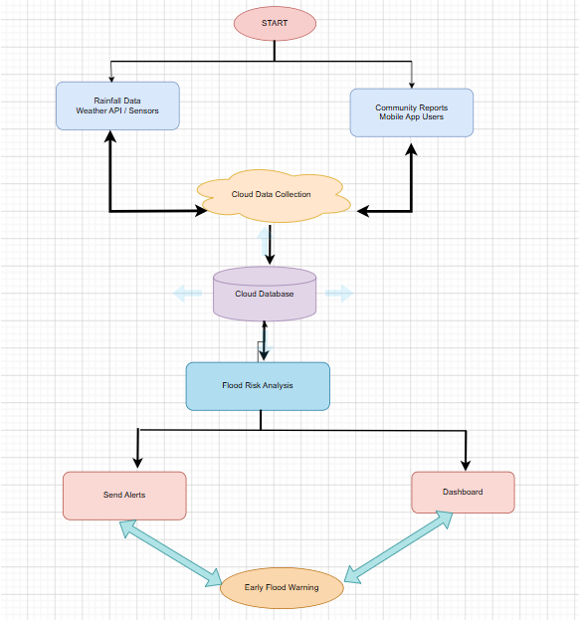

Brief explanation of your concept map: explain the most important nodes, link labels, hierarchy, and capstone connection. weather API integration.
The concept map is centered on the capstone project "Flood Watch Cloud Early-Warning App Using Rainfall Streams and Community Reports." The main node is connected to cloud computing fundamentals such as cloud definition, characteristics, service models, deployment models, virtualization, APIs, web services, scalability, and elasticity.
Cloud computing provides on-demand access to computing resources, making the application available anytime through the internet. The cloud architecture consists of the front-end mobile application, backend server, cloud database, analytics engine, and notification service.
The app collects rainfall data from weather APIs and community flood reports submitted by users. REST APIs are used for communication between the mobile application and cloud server. The cloud backend stores rainfall data, analyzes flood risk, and generates early warning alerts.
Virtualization enables multiple virtual servers to share physical hardware efficiently. Resource pooling, elasticity, and scalability allow the system to support thousands of users during heavy rainfall events without reducing performance.
The service models include Infrastructure as a Service (IaaS) for virtual machines, Platform as a Service (PaaS) for application development, Software as a Service (SaaS) for end-user access, and XaaS for weather API integration.

Task 2 - Service Model Matrix
Complete the matrices by making technical decisions for your capstone project. Select only the rows that are relevant to your capstone design. If a row is not used, write a short technical reason instead of leaving it blank.
Your answer should show how responsibility shifts between cloud provider and student development team, and how the chosen services support the capstone workflow, API design, storage, security, scalability, and evidence submission.

Task 2A - Service Model Responsibility Matrix
Service Model | Capstone Role / Module | Provider Responsibility | Student Responsibility | Evidence to Submit
IaaS | Cloud Server & Virtual Machines | Provide virtual servers, networking and storage | Deploy backend application and manage server configuration | VM Screenshot
PaaS | Backend Development | Runtime environment, application hosting, database services | Develop APIs, business logic and testing | Application Deployment
SaaS | Flood Watch Mobile/Web Application | Software availability and uptime | User interface design and feature development | App Screenshots
XaaS / Specialized Service | Weather API & Notification Service | Provide rainfall data, SMS and push notification services | Integrate APIs and handle responses | API Integration Screenshot

Task 2B - Capstone Cloud Service Decision Matrix
Cloud Layer / Function | Selected Tool or Service | Data / Resource Handled | API or Integration Path | Security / Scaling Note
Client access and UI | Android App | User reports | REST API | HTTPS Encryption
API / backend logic | Firebase Functions | Rainfall processing | REST API | Auto Scaling
Authentication and identity | Firebase Authentication | User Login | OAuth API | Secure Authentication
Database / structured records | Firebase Firestore | Rainfall data, reports | Database API | Access Rules
File / object storage | Firebase Storage | Flood images | Storage API | Encrypted Storage
Monitoring / logs / usage metrics | Firebase Analytics | Usage Logs | Analytics API | Real-time Monitoring
Analytics / reporting output | Google Data Studio | Flood Analytics | Dashboard API | Scalable Reporting
Technical justification: Explain why the selected cloud service pattern fits your capstone project's users, data, API flow, scalability, and security needs.
The selected cloud services are suitable because the Flood Watch application receives continuous rainfall information and community flood reports from many users simultaneously. Cloud infrastructure provides reliable storage, automatic backup, and high availability. REST APIs enable smooth communication between the mobile application, weather services, and cloud database. Firebase Authentication secures user accounts, while Firestore stores structured data efficiently. Auto-scaling ensures that the application continues to perform well during emergencies when thousands of users access the system. These cloud services provide flexibility, scalability, security, and cost-effective resource management for the flood warning application.
The selected cloud services are suitable because the Flood Watch application receives continuous rainfall information and community flood reports from many users simultaneously. Cloud infrastructure provides reliable storage, automatic backup, and high availability. REST APIs enable smooth communication between the mobile application, weather services, and cloud da

Task 3 - Capstone Cloud Flow Mapping
Study the sample architecture-flow template below. Redraw it in draw.io / diagrams.net using your own capstone architecture. Replace every generic label with your actual user role, screen, API endpoint, backend logic, cloud storage, analytics output, security control, and scalability or elasticity decision.
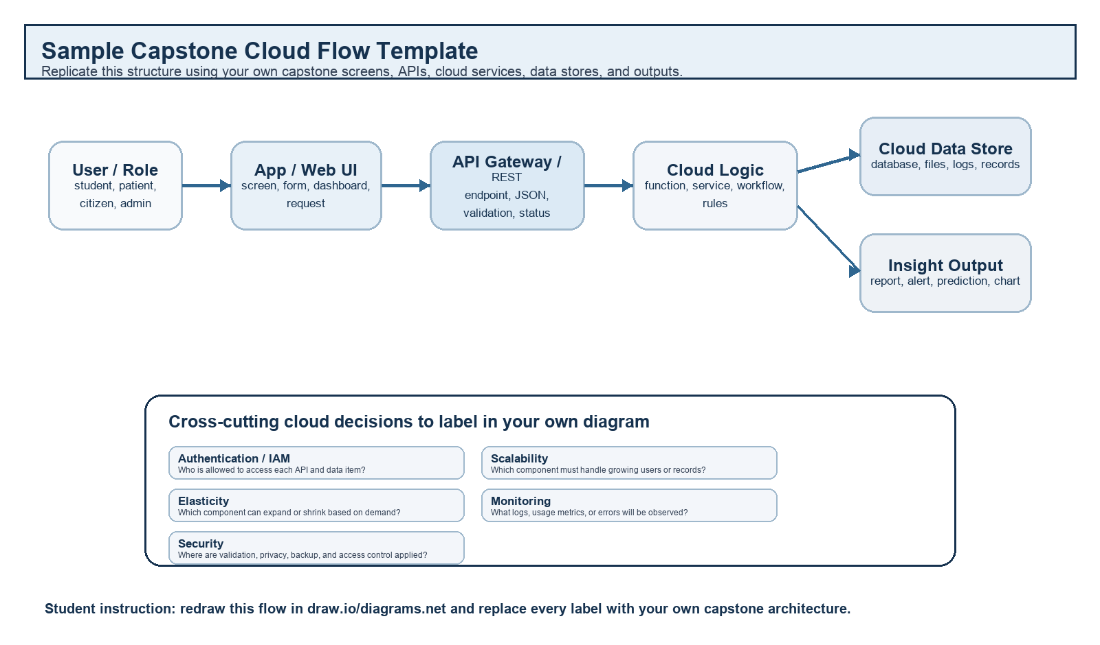
Student Drawing Requirement
Do not copy the sample as it is. Use it as a layout model, then create your own capstone-specific flow diagram with meaningful labels, arrows, data movement, API names, and cloud service choices.
Flow Component | Student Entry
User role and action | Citizen reports heavy rainfall or flooded area through the mobile application.
Frontend / app screen | Flood Report Screen
API endpoint and method | POST /api/flood-report
Backend processing rule | Validate user input.
Cloud database / storage operation | •User reports  • Rainfall records  • Flood locations  • Alert history
Response, alert, report, or dashboard output | • Flood Risk Level  • Safety Instructions  • Nearby Safe Shelters
Security, scalability, and elasticity labels added in diagram | • HTTPS  • Firebase Authentication  • Role-based Access
Paste your redrawn capstone cloud-flow diagram here.

Brief explanation: explain one complete request-response path from user action to cloud response.
When a citizen submits a flood report using the mobile application, the report is sent to the cloud server through a REST API. The backend validates the information and retrieves rainfall data from the weather service. The cloud analytics engine compares rainfall values with predefined flood thresholds and determines the flood risk. The processed information is stored securely in the cloud database. If the risk level is high, emergency notifications are immediately sent to nearby users and authorities. The dashboard is updated in real time so that disaster management teams can monitor flood conditions effectively.

Task 4 - Individual Reflection
Answer the following from your own perspective. Avoid team-common wording.
1. What is the strongest cloud concept represented in your capstone project?
The strongest cloud computing concept in my capstone project is real-time cloud data processing and scalability. Cloud services continuously collect rainfall data and community reports, analyze them instantly, and provide early flood warnings to users. The cloud ensures fast processing, reliable storage, and high availability even during emergency situations. loud computing concept in my capsnd community reports, ana
2. Where will elasticity or scalability become important in your capstone product?
Elasticity and scalability become important during heavy rainfall or natural disasters when thousands of users simultaneously access the application to report floods or receive alerts. Cloud resources automatically increase to handle the additional workload and reduce again after demand decreases, ensuring uninterrupted service.

3. Which API or web-service idea is most relevant to your project and why?
REST API is the most relevant web service because it enables secure and efficient communication between the mobile application, weather services, cloud database, and notification system. REST APIs support real-time data exchange, making flood prediction and alert generation faster and more reliable.

4. What did you personally understand better after preparing this concept map and matrix?
After preparing the concept map and service model matrix, I gained a better understanding of cloud architecture, service models, virtualization, REST APIs, scalability, and elasticity. I also learned how different cloud services work together to build a real-time disaster management application that is secure, reliable, and capable of serving a large number of users.

Evaluation Rubric - 100 Marks
Criteria | Marks | Expected Standard
Concept identification | 20 | Major CO1 concepts are accurately identified: cloud fundamentals, characteristics, evolution, service models, deployment models, virtualization, web services, SOAP/REST, APIs, elasticity, and scalability.
Relationship mapping | 20 | Links between concepts are accurate, meaningful, and labeled. The map should explain how concepts depend on, enable, consume, provide, scale, or control one another.
Hierarchy and organization | 15 | Concepts are arranged in a logical hierarchy with clear grouping, readable flow, and no disconnected keyword clusters.
Technical relevance | 15 | The map strongly reflects cloud course content and avoids decorative or generic non-technical content.
Service model matrix | 15 | IaaS, PaaS, SaaS, and XaaS are compared with provider responsibility, user responsibility, examples, capstone usage, and risks or limitations.
Capstone alignment and individual reflection | 10 | The student's own capstone interpretation is visible in the concept map, flow mapping, justification, and reflection. Team-common answers are avoided.
Visual clarity and digital evidence | 5 | Diagram is neat, readable, exported properly, and supported with GitHub evidence including source and exported files.

Faculty Evaluation Record
Evaluator Name |  | Marks Awarded
Observation |  | Signature

